PROGRAM ANIMACIJE-ANIMATIOM PROGRAM, 21-23.9.2023

ČETRTEK-THURSDAY | PETEK-FRIDAY | SOBOTA-SATURDAY
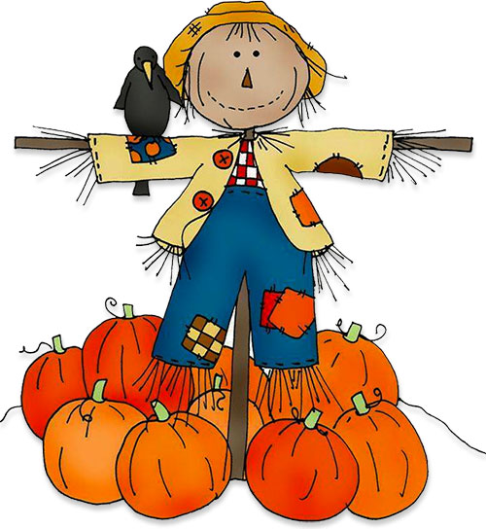 |  | 10.00-12.30  SPREHOD DO JEZERA JASNA  WALK TO JASNA LAKE  *prijave dan pred izletom do 18.00 ure, recepcija hotela/sign in a day before until 6.00 p.m., hotel reception  V primeru slabega vremena izlet odpade/in case of bad weather, the trip will be canceled  ZAČETNA TOČKA/MEETING! !POINT: RAMADA RESORT HOTEL
16.00-19.00  ODPRTA IGRALNICA/OPEN PLAYROOM  -kreativna delavnica/creative workshop  Kje/where: Ramada Resort | 15.30-18.00  ŠPORTNO POPOLDNE PRI KOČI TETE PEHTE/LET`S DO SOME SPORT AT AUNT PEHTA`S COTTAGE  Kje/where: za hotelom Ramada Resort/behind Ramada Resort hotel  *v primeru slabega vremena, odprta igralnica v Ramada Resort hotelu | 16.00-19.00  POSLIKAVA MAJIC  T-SHIRT PAINTING  *prijave na delavnico do 14.00 ure, na dan delavnice-recepcija hotela/sign in until 2.00 p.m., hotel reception  Cena/price: 6 evrov-euro/osebo-person  Kje/where: Ramadsa Resort, igralnica-playroom
 | 18.30-20.00  MINI POSLIKAVA OBRAZA  Mini face paint  Kje/where: Ramada Resort, igralnica-playroom

